**Missing Values :-**Using the.isnull() function in pandas to thoroughly analyze the diabetes dataset, it was discovered that none of the columns contained any missing values. This demonstrates that the dataset is comprehensive, will all records containing valid data.

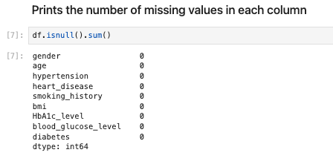

**Errors:-** No such error was detected  
  
**Outliers:-** To assess the potential presence of outliers in the dataset, we applied a combination of visualization techniques and statistical methods. This research led us to conclude that the data do not contain any notable outliers. The dataset's data points do not contain extreme values that would be considered outliers and do not deviate from predetermined thresholds.